Purpose
The purpose of this report is to present a summary of the 2020 EU Real Estate Technical Appraisal team’s achievements.

Analysis
In 2020, the DD team included 7 members: 5 DD managers (DDM) (vs. 4 in 2019), 1 Testfit manager and 1 Sr manager. Fabrice Rimlinger replaced Steve Griffiths in May 2020 as team leader. (Appendix 1).
Sites surveyed (Appendix 4):
The team received 686 requests for DD (vs 312 intakes in 2019 and 133 intakes in 2018 – Appendix 2). This represents an average of 137 intakes/DDM, an average of 39 sites handled simultaneously, with a maximum of 47 simultaneous sites per DDM in Nov’20 (Appendix 3). In addition, the team delivered approx. 200 site 1-pager Quick Checks (95% for DE – not tracked in SHIELD).
AMZL represented 67% of sites scoped (460 sites) and Core 17% (118 sites). AMZL DE, AMZL UK and AMZL IT altogether represented more than 50% of sites surveyed. The sites scoped were evenly distributed across main geographies (approx. 210 (30%) in DE, UK and SEU and 10% for MENA and small countries).
168 parking sites were reviewed in 2020 (vs. 15 in 2019), incl. 120 for AMZL. Electric Vehicle feasibility was requested for 47 parking sites (incl. 46 AMZL).
Tesfits and Layouts (Appendix 5):
In S2’20 (no tracker in place before Jun’20), 157 tesfits (TF) were conducted for 108 unique locations (86 core and 22 Sortation centers), with a maximum of 70 test-fits handled simultaneously. An average of 1.55 TF/site were delivered for Core (1.9 TF/site & 82% of TF discarded for Core UK) and 40% of these TF were successfully brought to DR0. For SC, 1.09 TF/site were generated (1.5 for SC IT), 33% of which made it to DR0.
DD durations (Appendix 6):
In average, it took 81 days from intake to latest report received (82 days in 2019) to run a full DD, including Phase I & Phase II surveys. Environmental DD is the long lead item, w/ 41days (49 in 2019) for a Phase I report and 54 days (111 in 2019) for a Phase II report (RFQ to report received). Environmental Phase I were conducted on 29% of sites scoped (vs. 18% in 2019 and 5% in 2018).
DD cancellations (Appendix 7):
Information Out of 686 DD initiated, 153 (22%) were cancelled before receiving the full set of reports (vs. 93 sites, 30% in 2019). With a cancellation rate of 18%, AMZL (84 out of 460 sites) represented 55% of DDs stopped in flight, for 67% of sites scoped. Core had a 31% cancellation rate (36 sites out of 118), SC 30% (10 out of 33) and GSF 46% (12 out of 26). AMZL DE’ cancellations are over-represented w/ 28% total cancellations for 22% of sites scoped. AMZL SEU is more accurate w/ 9% of cancellations for 22% of sites scoped. DE cancellations are over-represented for all business lines, w/ 41% of cancellations for 32% sites scoped in 2020. DDs are cancelled in 51% of occurrences once DDs are completed and 27% during Phase 1. Regarding cancellation reasons, 42% of occurrences are related to RE transaction issues (LL negotiation, site lost to 3rd party). The business is the source of 32% of sites dropped during DD (PMO or launch team, changes in POR) and DD flags 22% (major environmental concerns or traffic issue).
DD expenditure:
Extrapolated from Q4’20 PO data -Pending receiving FY data from Coupa - In 2020, 2,548 PO lines were created (vs.1094 in 2019) for a FY total of approx. 13.3M€. We spent 20.8k€ per site scoped, or 5,218€ per PO and 4.0 reports per site (vs 3.6 in 2019). Approx. 3.2M € were spent on cancelled sites.
Projects delivered by the DD team in 2020
A customer satisfaction survey, run in Sept’20 showed that the EU RE DD team earned trust of their stakeholders and is regarded as a supportive, engaged and reactive team. The team’s expertise is widely recognized, as the team provides accurate and comprehensive reports.
The Purchase Order (PO) process was updated in June’20 as a priority, to ensure that suppliers systematically provide quotes and Amazon POs are issued before consultant begin their mission. The DD team is now 100% compliant w/ AMZ policy. The PO approval/emission process lasts3 to 4 days, covering DD Intake, RFQ to suppliers, PR created and PO issued to consultants. This time is used to collect information from TMs and as buffer time for early cancellation.
Following AMZL EU internal audit, the DD team reviewed the compliance of their 29 suppliers, ensuring that NDAs, MSAs and rate cards are compliant w/ Amazon policies and properly signed by both parties. (Appendix 9)

- SHIELD EU RE DD page was created in 2019. In 2020, 33 SIM tickets were created to upgrade or fix these pages. The main upgrades were:
  - Creation of a “DD logbook” feature, allowing live note taking directly in SHIELD during calls, with a specific area to capture WHS latest status and comments. SHIELD has become the only tool used by the team to track DD process.
  - Addition of Electrical Vehicles feasibility surveys as a standard DD topic.
  - Addition of an “Action item tracker” feature, allowing DDMs to assign a task to D&C team whenever critical item is flagged in a DD report.
- New DD tools developed in 2020
  - Purchase orders tracker on SharePoint, allowing to track PO issues and manage consultants backlog.
  - Excel based “DD summary publisher” to automatically create PDF DD summaries from SHIELD data.
  - “GPS coordinates checking” tool, allowing to check whether a site was already scoped and to show the nearest sites already in SHIELD. (Appendix 8)
  - Creation of Standardized DD intake forms (incl. DD, Layouts and Quick Checks intake), seeking to improve the quality of information provided by brokers and TMs before instructing DDs. (Appendix 10)
- Integration of new DD suppliers:
  - Out of 36 active DD consultants, 10 suppliers were onboarded in 2020, to increase the DD bandwidth and reduce our dependency on few consultants.

2021 DD roamap
In 2021 the DD team will address in priority the following challenges:
- Manage the increasing volume of DD requests, w/ limited resources, knowing that process improvements are limited.
- Deliver DD results faster to proceed w/ lease signature as soon as possible and enable the launch in line w/ the POR.
- Accurately configure procurement systems to reduce administrative churn (POs blocked because of Payee Central or Coupa setups)
- Educate stakeholders on the benefits of accurate DD and the importance of properly documented DD intakes

The team plans to deliver the following projects in 2021:
Done – Outsource the Quick Check reports, with blanket POs for 5 to 10 reports to eliminate administrative latency.
Q1’21 - Hiring 2 DDMs: 1 DD manager for SEU (Environmental SME) and 1 DD manager for MENA + new geographies.
Q1’21 - Run a Suppliers performance benchmark – requested by AMZL 2020 internal audit.
Q1’21 - Standardize and simplify DD report comments to improve readability.
Q2’21 - Integrate Core and SC traffic patterns and shift patterns in the BRS SHIELD page.
Q2’21 - Launch a first version of PowerBI automated report online to manage the team workload and performance.
Q1’21 - Deploy an “Intake quality” metric in SHIELD.
Q2’21 - Takeover of DD approval ensure consistency of DD Approvals.
Q3’21 - Integrate the “GPS coordinates checking” tool in SHIELD.
Q3’21 - Integrate WHS specific fields in EU RE DD SHIELD pages.
TBC – Integrate Coupa information in SHIELD for improved budget tracking.

Appendices
Appendix 1 – DD workload evolution – 2017 to 2021 (forecast)

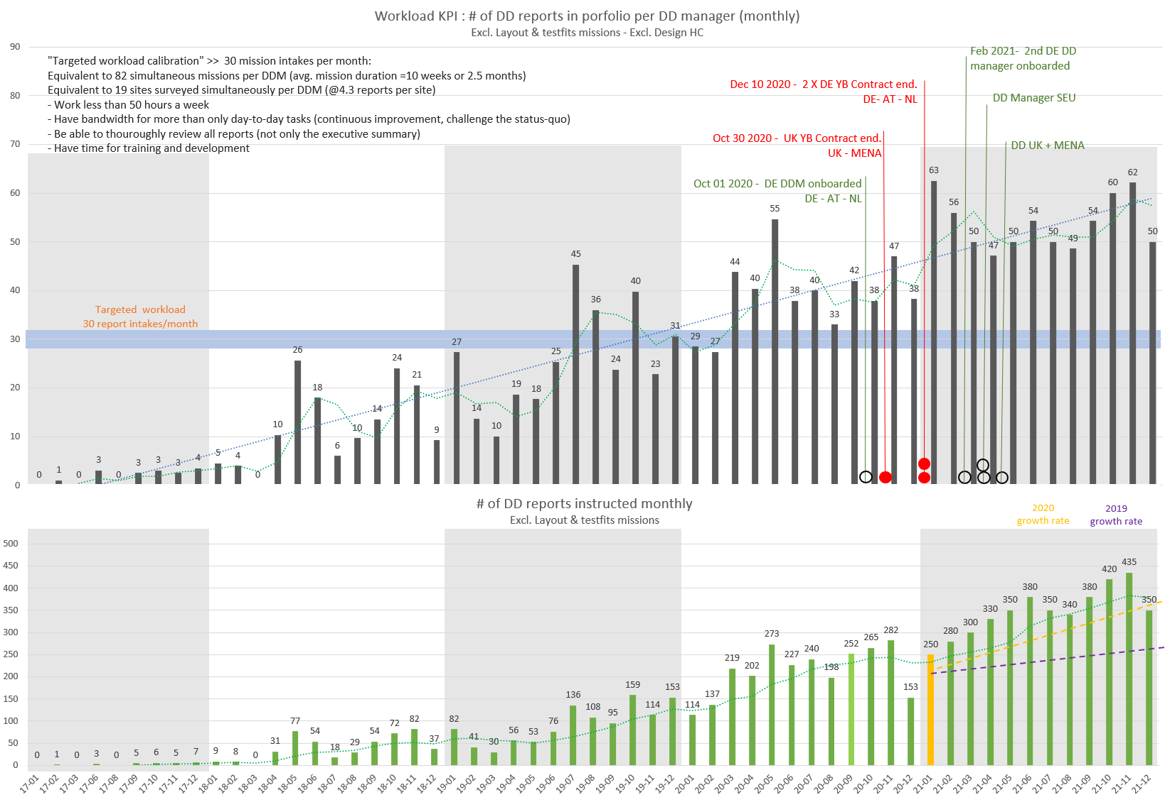

Appendix 2 – Evolution of the number of DD intakes – 2017 to 2020 (Total = 686 sites – Source: SHIELD)
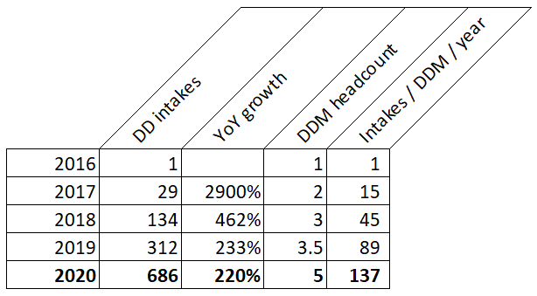

Appendix 3 – 2020 DD expenditure (extrapolated from Q4’20 data on DD SharePoint tracker)
Appendix 4 – DD team headcount and workload evolution – DD team main milestones -– Evolution 2017/2021
Appendix 5– Distribution of Sites scoped in 2020 (Total = 686 sites – Source: SHIELD)

Per business line

Per Country
Per business and Country
Appendix 6 – Testfits (TF) conducted in 2020 (Starting June 2020 – No tracker before this date)

Appendix 7 – Due Diligence Durations

Appendix 9 – DD Standard Timeline
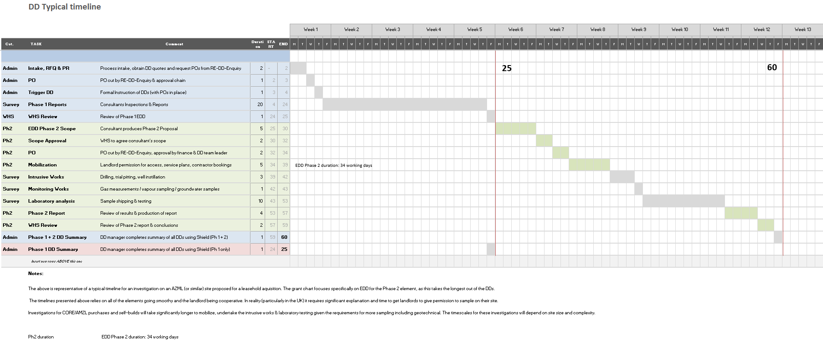
Appendix 8 – DD Cancellations
Appendix 9 – GPS Check tool Listing the 10 nearest sites already scoped, w/ links to SHIELD, Workdocs and Google maps

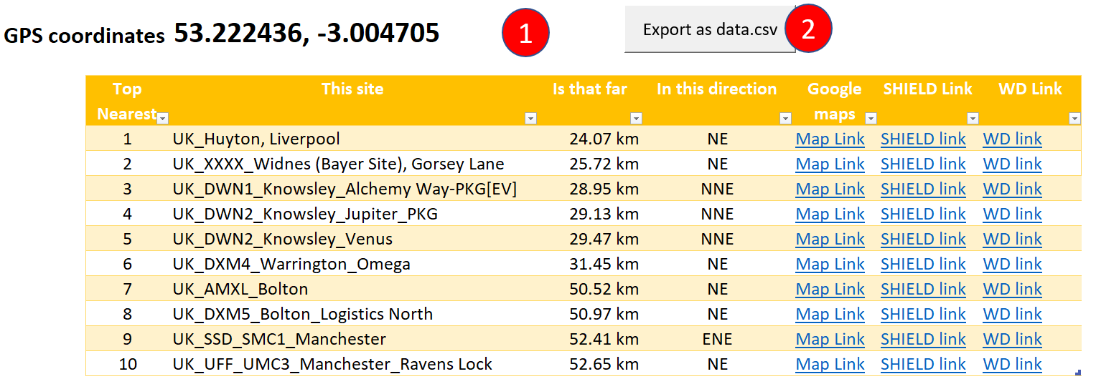

Appendix 10 – Suppliers Compliance tracker (NDAs, MSA, Rate cards, Contract central, Payee central)

Appendix 11 – Testfits intake form (from DD wiki page)
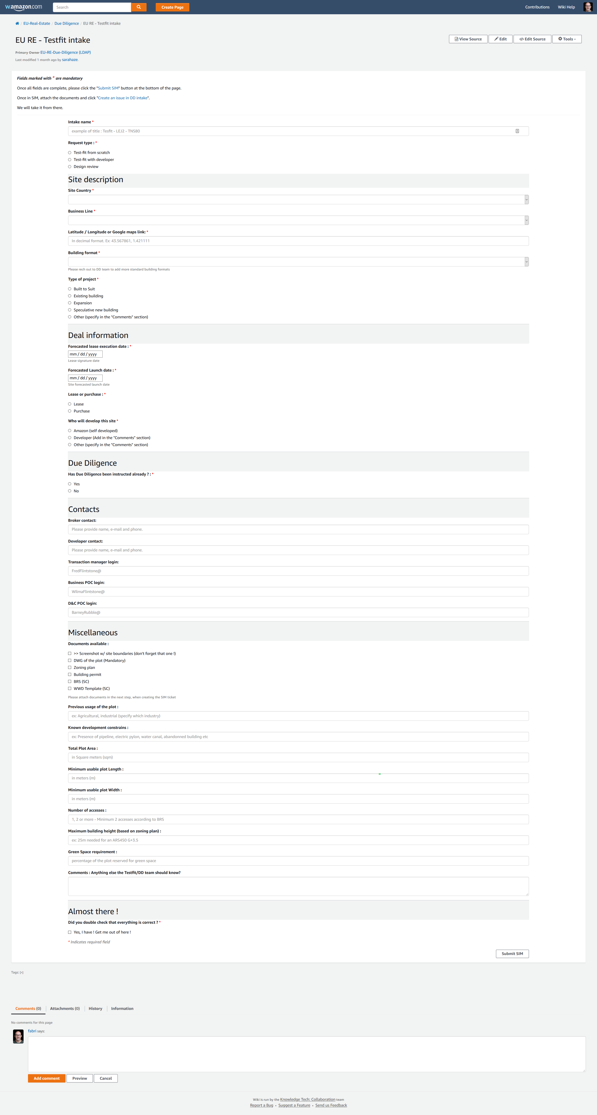
Appendix 12 – Due Diligence intake form (from DD wiki page)
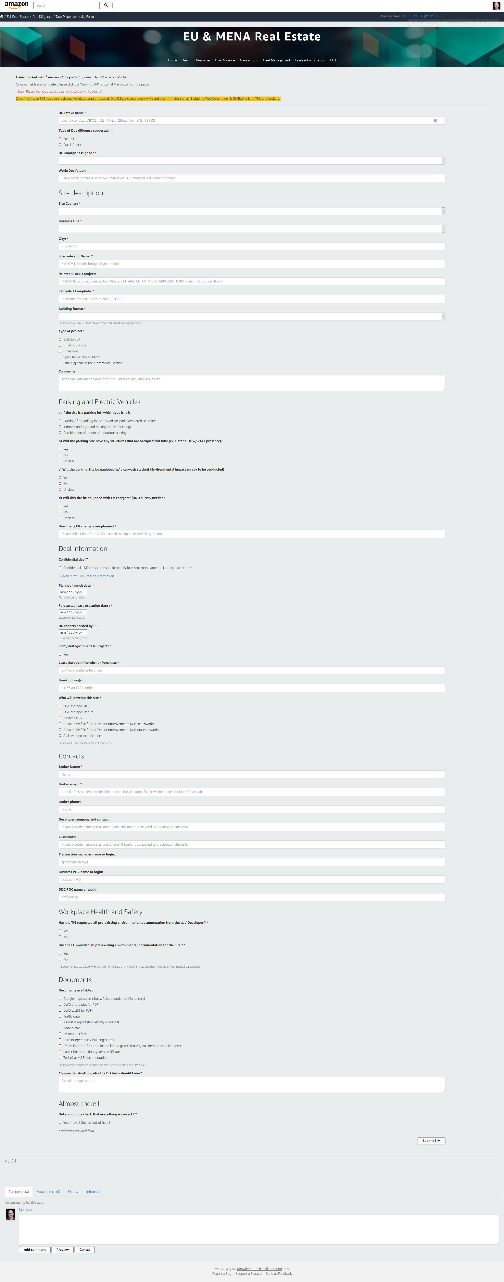 | 

